- Name | Subject Class | Class | Index  Number
 | 2BIX01



ANGLO-CHINESE JUNIOR COLLEGE
Preliminary Examination 2021

BIOLOGY 8876/02
26 August 2021
HIGHER 1 2 hours

Paper 2 Structured & Free-response Questions
For Examiner's Use
1
2
3
4 or 5
Total | 60

READ THESE INSTRUCTIONS FIRST

Write your name, index number and class on the top of this page.
Write in dark blue or black pen.
You may use a soft pencil for any diagrams, graphs or rough working.
Do not use staples, glue or correction fluid.

Answer all questions in the spaces provided on the Question Paper.
No additional materials are required.

The use of an approved scientific calculator is expected, where appropriate.
You may lose marks if you do not show your working or if you do not use appropriate units.

The number of marks is given in brackets [ ] at the end of each question or part question.

this question paper consists of 13 printed pages.
Section A

Answer all the questions in this section.

- Fig. 1.1 is an electron micrograph of part of a eukaryotic cell.
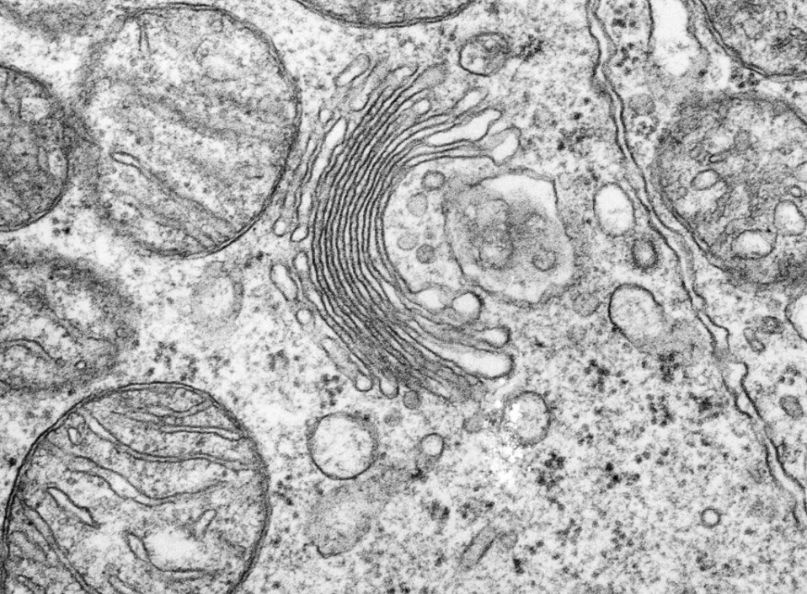

G

Fig. 1.1

(a) Both the Golgi body and the rough endoplasmic reticulum are part of the network of membranes inside cells.

 | (i) | Describe the structural features shown in Fig. 1.1 that identify G as the Golgi body and not the rough endoplasmic reticulum.
 |  | - Flattened sacs/cisternae which have a layered appearance / series of stacked membranes;
 |  | - Not interconnected / with no connection between membranes;
 |  | - Not connected to the (outer membrane of the) nuclear envelope;
 |  | - Swellings at the end of sacs indicate vesicle formation;  - Ribosomes are absent; @ 1m | [2]

 | (ii) | The nucleus contains genes which code for proteins found in other cellular organelles such as the Golgi body. Substances involved in protein synthesis move in and out of the nucleus. Describe and explain the movement of these substances.
- The presence of nuclear pores provides the passage for these substances;
- mature mRNA moves out of nucleus to ribosomes in cytoplasm for translation;
 |  | - Ribosomal subunits move out of nucleus to cytoplasm to form ribosome;
 |  | - tRNA moves out of nucleus to cytoplasm to undergo amino acid activation/be involved in translation;
 |  | - Ribosomal proteins move into nucleus from cytoplasm to form ribosomal subunits;
 |  | - Free ribonucleotides move into nucleus from cytoplasm to form mRNA/tRNA; @ 1m | [3]
(b) Outline how proteins are synthesised after the ribosome binds to the mRNA.
- mRNA is used as a template for translation;
- Anti-codon of aminoacyl tRNA binds with codon of mRNA via complementary base pairing;
- Peptidyl transferase catalyses the formation of peptide bonds between amino acids;
- Ribosome moves along mRNA in 5' to 3' direction until the stop codon (UGA, UAA, UAG) is reached;
- Polypeptide released undergoes folding / post-translational chemical modification in the RER or Golgi apparatus (to form a functional protein);
@ 1m | [4]

[Total: 9]

- Mangroves are plants that live in freshwater swamps and along salt water shoreline areas as shown in Fig. 2.1. They are mainly found in the tropics and subtropics, acting as nurseries for numerous species of birds, fish, crustaceans and shellfish.

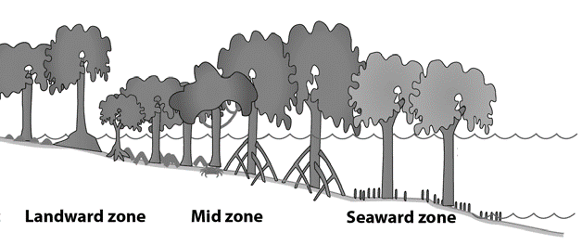
High tide

Mean sea level
Fig. 2.1

Mangroves are able to live in harsh coastal conditions through various adaptations. One such adaption is the ability to grow in low oxygen concentrations in waterlogged mud. Mangroves have lateral roots known as pneumatophores that grow upward out of the mud and water to absorb gases directly from the atmosphere as shown in Fig. 2.2.
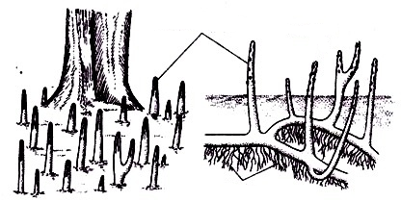
Pneumatophores

Normal roots

Submerged roots

Fig. 2.2

(a) | (i) | Explain how mangrove plants with more pneumatophores are able to yield more ATP per molecule of glucose.
- Plants with more pneumatophores are exposed to more (atmospheric) oxygen and can undergo more aerobic respiration / less anaerobic respiration as compared to plants with fewer pneumatophores

OR complete/incomplete oxidation of glucose;
 |  | - Cells of pneumatophores can synthesise 38 ATP which is more compared to cells of submerged roots which can synthesise 2 ATP from 1 molecule of glucose  OR idea of 19 times more ATP can be synthesised from 1 molecule of glucose; | [2]

A group of scientists aims to investigate how well different species of mangroves grow along a river mouth in India. The mean height and total biomass (the amount of living tissue mass of a population) of four mangrove species were recorded as shown in Table 2.1.

Table 2.1

mangrove species | mean height (m) | total biomass (arbitrary units)
Bruguiera gymnorrhiza | 7.28 | 0.510
Lumnitzera racemose | 9.56 | 1.273
Excoecaria agallocha | 8.92 | 0.958
Ceriops tagal | 6.74 | 0.263

 | (ii) | Explain how the products of respiration and photosynthesis contribute to the biomass of plants.
 |  | - ATP synthesised from respiration is needed in many processes, such as cell division / AVP;
 |  | - (GALP is converted to) Glucose synthesised from photosynthesis/Calvin cycle is used to form starch which serves as an energy storage;
 |  | - (GALP is converted to) Glucose synthesised from photosynthesis/Calvin cycle (see once) can also be used to form cellulose which is used in the synthesis of cell walls
 |  | - AVP; | [2]
* Need to mention at least 1 product from respiration and 1 product from photosynthesis to get full marks

 | (iii) | Describe the relationship between the mean height and total biomass of mangroves shown in Table 2.1.
 |  | - There is a positive trend/correlation between mean height and total biomass;
 |  | - When mean height increased from 6.74m to 9.56 m, total biomass increased from 0.263 to 1.273 A.U.; | [2]

 | (iv) | Suggest whether the mean height or total biomass of mangroves is a more accurate indicator of plant growth and explain your answer.
 |  | - Total biomass;
- Height of tree does not take into account other factors such as leaf mass or root mass, but total biomass takes into account above- and below-ground tissue mass;
OR
trees may be wide but not tall, hence total biomass can take into account the amount of living tissue mass in wide trees but height of tree does not;
 |  | - AVP; | [2]

 | (v) | Explain how climate change may result in the drowning of mangroves.
 |  | Question removed due to CLT
 |  |  | [3]

Mangrove forests are good carbon sinks as they absorb more carbon dioxide from the atmosphere than they release. One of the proteins involved in this role is ribulose bisphosphate carboxylase-oxygenase (rubisco) that is found in the chloroplasts of mangroves as shown in Fig. 2.3. Rubisco has an active site that has a complementary 3D configuration to carbon dioxide, allowing the formation of a rubisco-carbon dioxide complex.

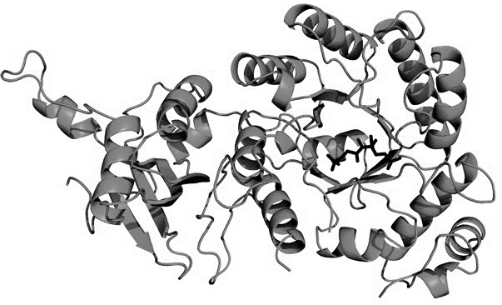

Fig. 2.3

(b) | (i) | State the region in the chloroplast where rubisco is found.
 |  | Stroma; | [1]

 | (ii) | Describe the local folding of the polypeptide chain to form regular structures in rubisco.
 |  | - There are α-helices and β-pleated sheets that make up the secondary structure;
 |  | - Maintained by hydrogen bonds between the –CO group and the –NH group within the same polypeptide backbone; | [2]

 | (iii) | Environmentalists are worried about how mangroves may no longer be an effective carbon sink in light of increased temperatures due to global warming.  With reference to the activity of rubisco, discuss whether the environmentalists’ worries are valid.
 |  | - As temperature increases due to global warming, kinetic energy of rubisco in Calvin cycle increases and there is a higher frequency of effective collisions between carbon dioxide molecules and rubisco;
 |  | - Leading to formation of more enzyme-substrate complexes and higher rate of Calvin cycle and hence mangrove forests act as better carbon sinks, thus the worries are not valid;
 |  | - However, if global warming causes temperatures to rise beyond the optimum temperature of rubisco, they start to denature/lose specific 3D configuration;
 |  | - Hence, there are fewer enzyme-substrate complexes and lower rate of Calvin cycle, hence their role as carbon sinks become diminished (in the long run), thus the worries are valid; | [4]

[Total: 18]

- Li-Fraumeni syndrome is a rare hereditary disorder that is associated with cancer development.

The disorder arises due to a mutation in the TP53 tumour suppressor gene occurring in germline cells. Scientists have made the following observations about the disorder:

- The TP53 gene is located on chromosome 17.
- Individuals with Li-Fraumeni syndrome are heterozygotic at birth, inheriting one copy of the mutated TP53 gene from one parent, and a normal copy from the other parent.

Fig. 3.1 shows the estimated probability of individuals with Li-Fraumeni syndrome being diagnosed with cancer in their lifetime when compared to normal individuals. Fig. 3.2 tracks a particular family’s history for cancer due to Li-Fraumeni syndrome.

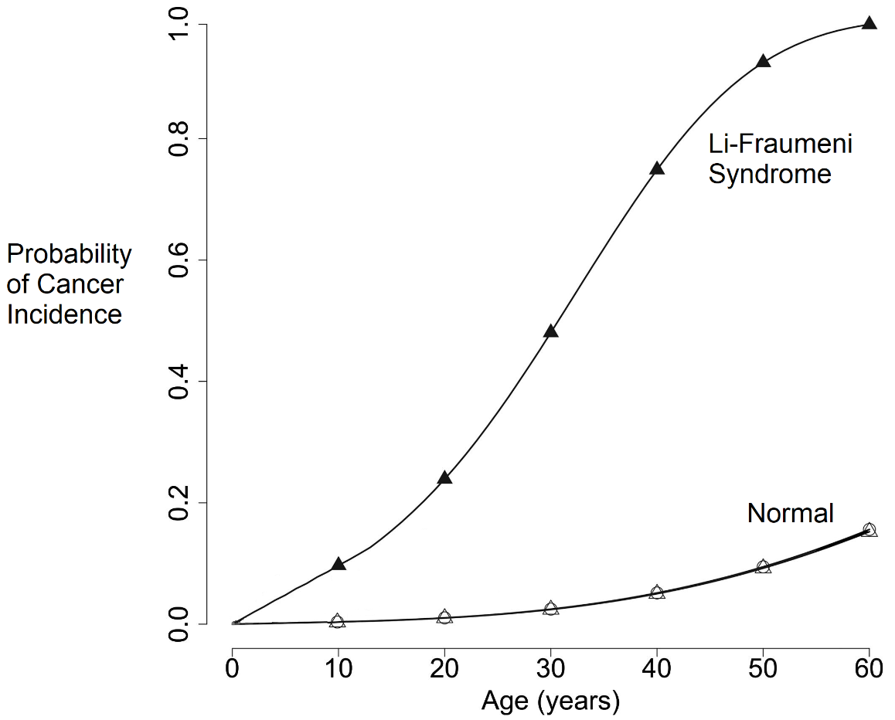

Fig. 3.1

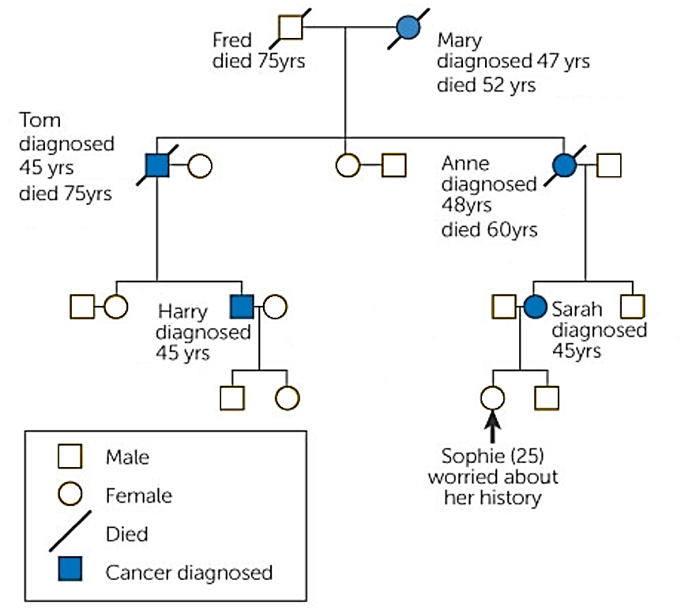
Fig. 3.2

(a) (i) Define what is meant by the term ‘germline cells’.
- Cells involved in sexual reproduction / formation of sperm and egg / formation of gametes OR gametes involved in sexual reproduction / sperm and egg;
[1]

(ii) With reference to Fig. 3.1, describe how Li-Fraumeni syndrome affects an individual’s probability of developing cancer.
- An individual affected by Li-Fraumeni syndrome has a higher probability of developing cancer when compared to normal individuals at all ages;
- From birth till 60 years of age, the probability of developing cancer in Li-Fraumeni individuals increases from 0.0 to 1.0, while the probability in normal individuals increases from 0.0 to 0.15 only;
- By 60 years of age, a person with Li-Fraumeni syndrome is expected (with a probability of 1) to have developed cancer;
[3]

Cancer development as a result of Li-Fraumeni syndrome is described as having an autosomal dominant inheritance.

(iii) Based on the information provided, explain how this mode of inheritance can be deduced.
Autosomal: | TP53 gene is found on chromosome 17, which is an autosome / non-sex chromosome;
Dominant: | Inheritance of one copy of the mutated gene / A heterozygous individual is expected to develop cancer by 60 years of age;
OR
Despite being a rare disorder, cancer is diagnosed in every generation of the family shown;
 |  | [2]

The TP53 gene codes for a protein that controls the transcription of other genes involved in the following functions:

- Repair of damaged DNA.
- Arresting the division of cells with damaged DNA.
- Initiating programmed cell death of cells with DNA that cannot be repaired.

It is known that one normal copy of the TP53 gene codes for sufficient proteins to maintain the functions listed above.

(iv) Explain how an individual who inherits one copy of the mutated TP53 gene may develop cancer in his lifetime.
- A mutation in the second normal copy of the gene is acquired / must occur;
- Through chemical carcinogen / ionising radiation (give one e.g.);
- Affected cells unable to code for any functional proteins that can initiate DNA repair / arrest damaged cells at cell cycle checkpoints / initiate programmed cell death (despite the mutations);;
- leading to the further accumulation of mutations in a single cell line;
- and these cells divide uncontrollably to form a tumour;
- Cancer cells induce the formation of capillaries towards it during angiogenesis;
- Cancer cells may spread to other parts of the body during metastasis;
*Pt 5 or 7 compulsory for full marks | [5]

Researchers explored using a technique known as gene therapy to treat patients with Li-Fraumeni syndrome, as shown in Fig. 3.3. Stem cells were removed from the patient, and a normal copy of the TP53 gene is inserted into the extracted stem cells. The genetically-corrected cells are re-introduced back into the patient.

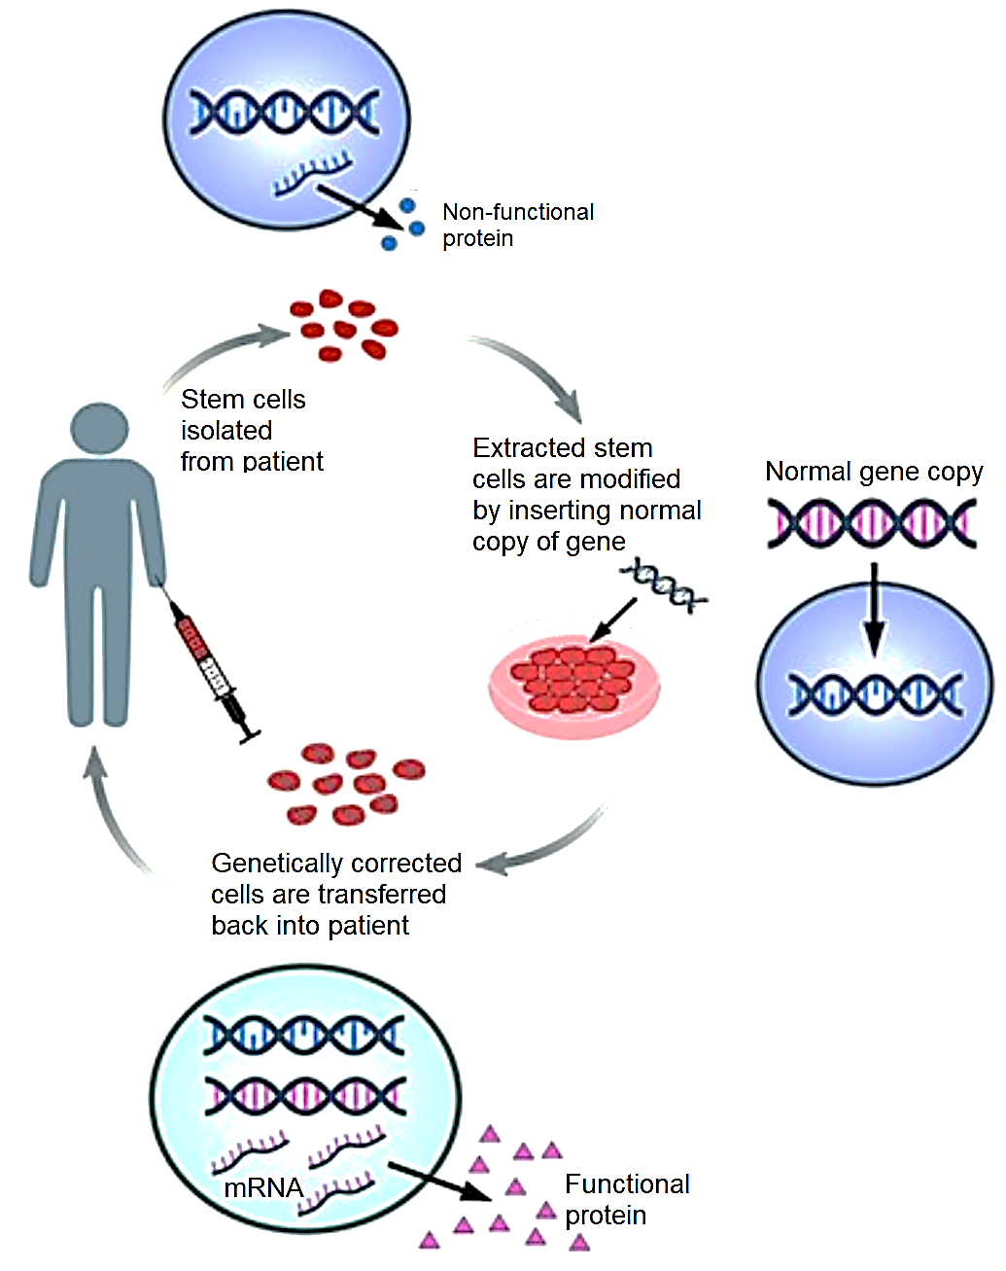
Fig. 3.3

(b) (i) Identify the type of stem cell extracted from the patient and describe the features of these stem cells.
- Adult stem cells / Somatic stem cells / Multipotent stem cells;
- They are capable of self-renewal / dividing continuously for a long period of time;
- They are undifferentiated;
- They can form progenitor stem cells which are able to differentiate into a limited range of cell types under the influence of appropriate chemical signals;
[4]

(ii) Comment on the ethical aspects of the gene therapy used to treat patients with Li-Fraumeni syndrome.
Ethical

- New therapy provides a possible cure to an incurable disease;
- Germline cells are not involved, so the inserted gene will not be passed on to the patient’s offspring;
- Patient’s own cells are used, eliminating the need to harvest embryos for pluripotent stem cells / eliminate the risk of exploitation of women for donation of ova or embryos;
- Patient’s own cells are used, hence cells and tissues generated are immunologically compatible;
Unethical

- Invasive / painful procedure of stem cell extraction;
- Potentially unknown effects of modifying the genome (e.g. insertion of gene copy could disrupt genes in the cell if insertion is incorrect / inaccurate);
- Only the rich has access to and can afford the gene therapy that come with high costs;
- Therapy is unlikely to be able to replace all cells in the patient’s body (since adult stem cells are used), hence limited in effectiveness;
[3]

[Total: 18]

Section B

Answer one essay question.

Write your answers in the writing paper provided.
Your answers should be illustrated by large, clearly labelled diagrams, where appropriate.
Your answers must be in continuous prose, where appropriate.
Your answers must be set out in sections (a), (b) etc., as indicated in the question.

4 | (a) | Describe the structure of a typical bacterial cell and suggest how bacteria secrete proteins in the absence of an endomembrane system. | [6]
 | (b) | Explain how meiosis plays a role in the continuation and evolution of the human population. | [9]

5 | (a) | Carbohydrates may form part of another biological molecule’s structure. Explain the various roles of carbohydrates in these biological molecules. | [6]
 | (b) | Using named examples, explain how genetic variation (including harmful recessive alleles) may be preserved in a natural population. | [9]

[Total: 15]

END OF PAPER

4 | (a) |  | Describe the structure of a typical bacterial cell and suggest how bacteria secrete proteins in the absence of an endomembrane system |  | [6]
Structure of bacterial cell (max 5)
- small;
- unicellular;
- has peptidoglycan cell wall;
- circular double-stranded DNA (found in nucleoid region);
- 70S ribosomes;
- lacks membrane-bound organelles;

bacterial protein secretion
- protein pores / protein channels are present in the cell surface membrane of bacterial cells;
- (Folded) proteins are then translocated across the channel (into the periplasm);
@ 1m

 | (b) |  | Explain how meiosis plays a role in the continuation and evolution of the human population. |  | [9]
Continuation of population:
- Meiosis allows for sexual reproduction;
- After two successive nuclear divisions, haploid gametes are produced;
- Two haploid gametes can then fuse to form a diploid zygote and hence a new individual is formed / restore ploidy;
- If meiosis did not occur, fusion of diploid gametes would result in doubling of chromosome number in each successive generation which prevents the formation of an individual and hence preventing continuation of the human population;

Evolution of population: Genetic variation
- Meiosis also allows for genetic variation;
- Crossing over between non-sister chromatids of homologous chromosomes during prophase I;
- Allow the formation of new combination of alleles;
- Independent assortment of homologous chromosomes occur in metaphase I;
- Allow formation of different combinations of maternal and paternal chromosomes in gametes;

Evolution of population: Natural selection
- This gives rise to variation in the population which is important for natural selection to act on;
- When there is a selection pressure, individuals which have a selective advantage will be selected for / individuals without a selective advantage will be selected against;
- Individuals with a selective advantage are have higher reproductive success, passing on alleles coding for advantageous traits to their offspring;
- Over time, there is an increase in frequency of allele coding for advantageous traits in the gene pool;

- QWC: At least one valid point from each of the three categories
Pts 5-13: Max 6
R! Random fusion of gametes as it is not part of the meiotic process

5 | (a) | Carbohydrates may form part of another biological molecule’s structure. Explain the various roles of carbohydrates in these biological molecules. |  | [6]
- Carbohydrates are found in glycoproteins, as oligosaccharides attached to proteins;
- Carbohydrates are found in glycolipids, as oligosaccharides attached to phospholipids;
- These glycoproteins / glycolipids are part of the cell surface membrane, with the carbohydrate / oligosaccharide portion facing the exterior of the cell;
- Carbohydrates form branched structures, conferring a unique / specific conformation to these glycoproteins / glycolipids;
- So that these glycoproteins / glycolipids can function in cell-to-cell recognition / cell-to-cell adhesion / cell signaling or act as receptor molecules / AVP e.g. oligosaccharides on proteins embedded in lysosomal membranes protect them from digestion by lysosomal enzymes;
- Carbohydrates are found as ribose sugar in RNA / ribonucleotides;
- Carbohydrates are found as deoxyribose sugar in DNA / deoxyribonucleotides;
- Carbon 1 of the pentose sugar attached to nitrogenous bases;
- Carbon 5 of the pentose sugar attached to phosphate group;
- Pentose sugar involved in forming the sugar-phosphate backbone of a RNA / DNA strand;
- OH group on carbon 3 of pentose sugar allows for the addition of nucleotides in an elongating strand of RNA / DNA;

5 | (b) | Using named examples, explain how genetic variation (including harmful recessive alleles) may be preserved in a natural population. |  | [9]
Diploidy
- In diploid organisms, recessive alleles are not phenotypically expressed in heterozygotes;
- are thus not influenced by selection pressures;
- Heterozygote containing the recessive allele will pass on the recessive allele to the offspring, preserving the allele in the population;
- e.g. heterozygous condition masks harmful recessive Hb^{S} allele that is less favourable from natural selection which only acts on sickle cell anaemia phenotypes;
A! heterozygous condition masks harmful recessive mutated cystic fibrosis allele that is less favourable from natural selection which only acts on cystic fibrosis phenotypes;

Heterozygote advantage
- Individuals that are heterozygous at a particular locus have higher reproductive success than both homozygotes and pass on the recessive allele to the offspring;
- e.g. Hb^{A}Hb^{S} do not die of sickle cell anemia or are more resistant to malaria in malaria infested areas;
- Both types of homozygotes display traits which are selected against;
- e.g. Hb^{S}Hb^{S} individuals will be disadvantaged due to serious effect of sickle-cell anaemia and Hb^{A} Hb^{A} will be susceptible to malaria;

Frequency-dependent selection
- fitness/selective advantage of phenotype depends on how common it is;
- Survival and reproduction of individuals of one phenotype decline if that phenotypic form becomes too common in the population;
- the frequency of each phenotype oscillates over time but is kept close to 50%, thus maintaining both types of alleles in the population;
- e.g. predators preferentially consume the most common type of prey, making a rare prey type to be at an advantage because it experiences lower predation than the more common prey types. This preserves rare alleles carried by the rarer prey type which could be recessive in nature among the prey population;

- QWC: addresses 2 points from 2 parts

@ 1m, max 10

